Scope
This assessment covers the User Access Review control for NexG Services Ltd, a fictional organization with 15 employees limited to user accounts and memberships within Microsoft Entra ID.
The assessment considers whether user access control is correct for the employees’ current job responsibilities and whether access is appropriately adjusted when employees receive different responsibilities or leave the organization

Control Objective
The objective of the User Access Review control is to ensure that user access is authorized, appropriate and aligns with employees’ current job responsibilities. This includes:
- Users receive only the access required to perform their assigned duties.
- Excessive or inappropriate access is identified and removed.
- Access is updated when an employee’s role or department changes.
- Access is removed when an employee leaves the organization.
- Evidence of the review, identified exceptions, approvals and remediation actions are retained.

Framework Mapping

Focus | Framework Mapping | Failure
User access appropriateness | NIST CSF 2.0 PR. AA-05 | Employees retain access beyond their current responsibilities because access permissions are not adequately reviewed against their assigned roles.
Access following role changes | ISO/IEC 27001:2022 A.5.18 & NIST CSF 2.0 PR. AA-05 | Employees retain outdated access after changing departments because access rights are not reviewed and modified following changes in responsibilities.
Access removal | ISO/IEC 27001:2022 A.5.18 & NIST CSF 2.0 PR. AA-05 | Departed personnel retain access because offboarding does not trigger timely review and revocation of their access rights.

Testing Methodology
- Identify the user accounts in Microsoft Entra ID
- Identify each employee’s current role, department and employment status
- Establish the expected responsibilities and status
- Review the group memberships in Entra ID
- Compare the expected access to the current access
- Identify findings
- Confirm findings
- Document findings
- Remediate exceptions by removing, modifying or disabling access
- Conclusion

Evidence to be collected

- Microsoft Entra ID user accounts
- Microsoft Entra ID groups
- User group memberships and access rights
- Expected v/s actual access
- Account status
- Identified access exceptions
- Post remediation access status

Findings
- Unnecessary Access
- Employee: Sarah Adams
- Role: Accountant
- Department: Finance
- Expected Access: Finance
- Actual Access: Finance and Marketing
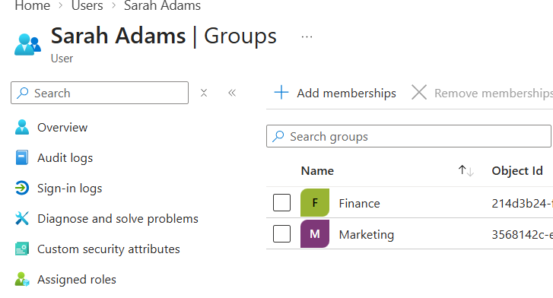
- Access not updated after department transfer
- Employee: Daniel Evans
- Former Role: IT support
- New Role: Sales Executive
- New Department: Sales
- Expected Access: Sales
- Actual Access: IT
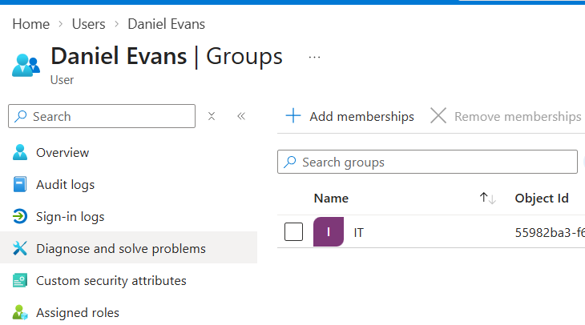

- Active Access Following Employee Resignation
- Employee: Emma Wilson
- Previous Role: Marketing Officer
- Department: Marketing
- Employee Status: Disabled
- Expected Access: No access
- Actual Access: Active Microsoft Entra account and membership in Marketing

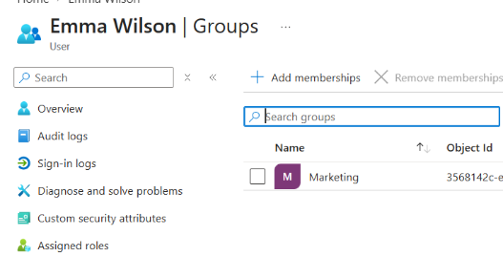
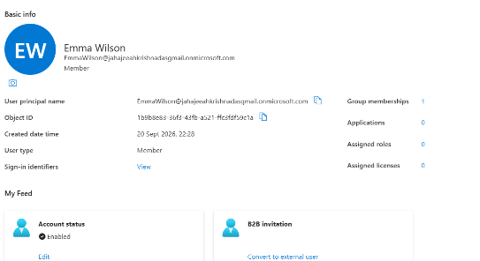

Executions

Tasked Performed | Action Taken
 | Identified excessive access and recorded the exception for remediation
  Reviewed employee roles and Microsoft Entra ID access permissions
Reviewed access for an employee following a department change
  Removed outdated access and updated group membership to match the employee's new responsibilities
Reviewed Microsoft Entra ID access for a departed employee | Disabled the account and removed associated access rights

Recommendations
- Implement a quarterly access recertification process where department managers confirm each employee's group memberships are still appropriate.
- Integrate department transfers with a mandatory access review step, so access is re-evaluated whenever an employee's role changes in HR records.
- Automate deprovisioning by linking employee termination in HR to immediate account disablement and group removal in Microsoft Entra ID, rather than relying on manual offboarding steps.

Conclusion
Based on the testing performed and evidence obtained, three access-management exceptions were identified, remediated, and verified: an employee with unnecessary department access had the extra privileges removed, a transfer from IT to Sales had outdated IT access revoked and appropriate Sales access assigned, and a departed employee's active Microsoft Entra account was disabled with all organizational access removed successfully demonstrating an end-to-end access-management control assessment process.

